CSE2006: Microprocessor and Interfacing

J Component Review 3

Volume Unit Meter



Submitted By:

Abinash Satapathy 16BCE0081

Rishabh Vallecha 16BCE0100

Saurav Panigrahi 16BCE0135

**Introduction**

The volume unit (VU) meter is a device that displays a representation of the signal level in audio equipment. It is used in some consumer audio equipment for utilitarian purposes such as in recording devices or for aesthetics like playback devices.The original VU meter is a passive electromechanical device, but using a few LEDs with a controller and some lines of code, we will be able to make an interesting digital VU meter device.

Volume Meter can be considered as an Equalizer, in which LEDs will shine as indicated by the force of the music. On the off chance that music is noisy then more LEDs will shine and if music is low then lesser number of LEDs will sparkle. Volume Meter (VU) is a pointer or portrayal of the power of sound level over LEDs and can likewise fill in as a volume estimation gadget.

In this Project, we are building VU Meter utilizing Arduino and taking the sound contribution from 3.5 mm jack, with the goal that you effectively give sound contribution from your Mobile or Laptop utilizing AUX chord or 3.5 mm jack. We are planning it on PCB as an Arduino Shield.

***Motivation:***

The VU meter that we are trying to develop is very economical as compared to the other sound recognition systems. We wanted to measure if the sound pollution factor can be kept checked by this machine because it is an indication to the level of noise. Noise pollution as it is known is increasing at a tremendous rate. Thus we will be able to keep a track of noise levels allowing being as less as possible.

***Significance of the Project:***

As said previously, a VU meter demonstrates the normal uproar of a sound. It demonstrates the vitality and power of the music. In blending, a VU meter demonstrates the real level of the blend. Noise pollution has truly begun to pick up significance because of high populace thickness. A typical human ear could hear sound levels from 0dB to 140dB in which sound levels from 120dB to 140dB are thought to be clamor. Tumult or sound levels are normally estimated in decibel(dB), we have a few instruments which could gauge the sound flags in dB yet these meters are somewhat costly and tragically we don't have an out of box sensor module to quantify sound levels in decibels. What's more, it isn't conservative to buy costly mouthpieces for a little Arduino venture which should quantify the sound level in a little classroom or lounge.

***Scope of the Project:***

Circuit for this Arduino Sound Level Meter is an extremely basic in which we have utilized Audio intensifier circuit to increase the signs from a condenser amplifier and supply it to the analog port of Arduino. This project is a very basic model of the VU meter. There exist VU meters which allow for music signal mixing. The circuit design and the apparatus are somewhat different than the one we’re designing. This project currently works with a basic headphones jack.

***Applications:***

The best place to use a VU meter is across a meter output on a monitor controller or console. That way we can select what you want to meter, and meter what we’re hearing. Failing this, we can try to connect it across a monitor DAC or on the inputs to an ADC after an analogue chain. Here we’ve tried using the basic headphones jack. This utilization can further be extended as well.

VU meters are very effective for people having a career in the music industry. It helps them generate a great mix. The VU meter can be calibrated so the end result of the music achieves the loudness or average volume that is desired. It shows the energy and intensity of the music. In mixing, a VU meter shows the actual level of the mix.

**Literature Survey**

***Existing Survey:***

Various forms of VU meters have been designed by college students in the past. We went through a lot of them, gathering information from all of them and getting to know where they lacked.

We took help from the following websites and journals:

<http://www.instructables.com/id/Arduino-Vu-Meter-Using-a-Sound-Sensor/>

<https://www.globalspec.com/learnmore/test_measurement_equipment/multimeters_electrical_test_meters/vu_meters>

<http://www.electronics-lab.com/arduino-based-vu-meter/>

The VU meters had the following problems:

* Some of the VU meters were unable to properly display the sound recordings that is being input.
* They were not very easy to carry. Construction was complex.

***Gaps Filled:***

The VU meter we have tried to implement offers the following advantages:

* Audio input is quite easy. Using a 3.5mm Audio Jack, the sound can be input.
* We have used various LEDs to depict the actual intensity of the music.
* The circuit connection is extremely easy to understand. The components are also readily available.
* The construction cost is less compared to the other systems. The apparatus is not very bulky and can be easily transported.
* The codes are easy to understand for beginners.

**Design and Implementation**

***Components Required:***

* Arduino Uno
* Breadboard
* Jumper wires (Male to male)
* Resistors (110k, 10k, 2200k) Total of 11
* LED lights (Red, Blue, Yellow and green) Total of 11
* 3.5mm audio jack

***Circuit Diagram:***

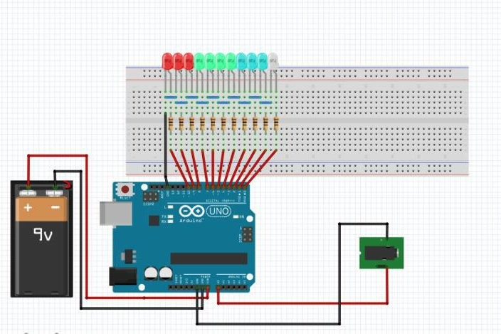

***Implementation Details:***

* Insert LEDs into Breadboard such that all Positive terminals are in same side.
* Insert Resistors into Breadboard in series with Positive terminal of the LEDs .
* Use Jumper wires to connect in series with resistor to Arduino digital pins.
* Upload the code into Arduino.
* Insert one wire of audio jack at A0 and another to GND.

***Code:***

int led[11] = {0, 1, 2, 3, 4, 5, 6, 7, 8, 9, 10};

int input, i;

void setup()

{

for (i = 0; i < 11; i++)

pinMode(led[i], OUTPUT);

//Serial.begin(9600);

}

void loop()

{

input = analogRead(A0);

//Serial.println(s);

input = input / 12;

if (input < 12)

{

if (input == 0)

{

for (i = 0; i < 11; i++)

{

digitalWrite(led[i], LOW);

}

}

else

{

for (i = 0; i < input; i++)

{

digitalWrite(led[i], HIGH);

delay(4);

}

for (i = i; i < 11; i++)

{

digitalWrite(led[i], LOW);

}

}

}

}

**Test Cases:**

* Rock Music
* Jazz Music
* Country Music

**Snapshots**

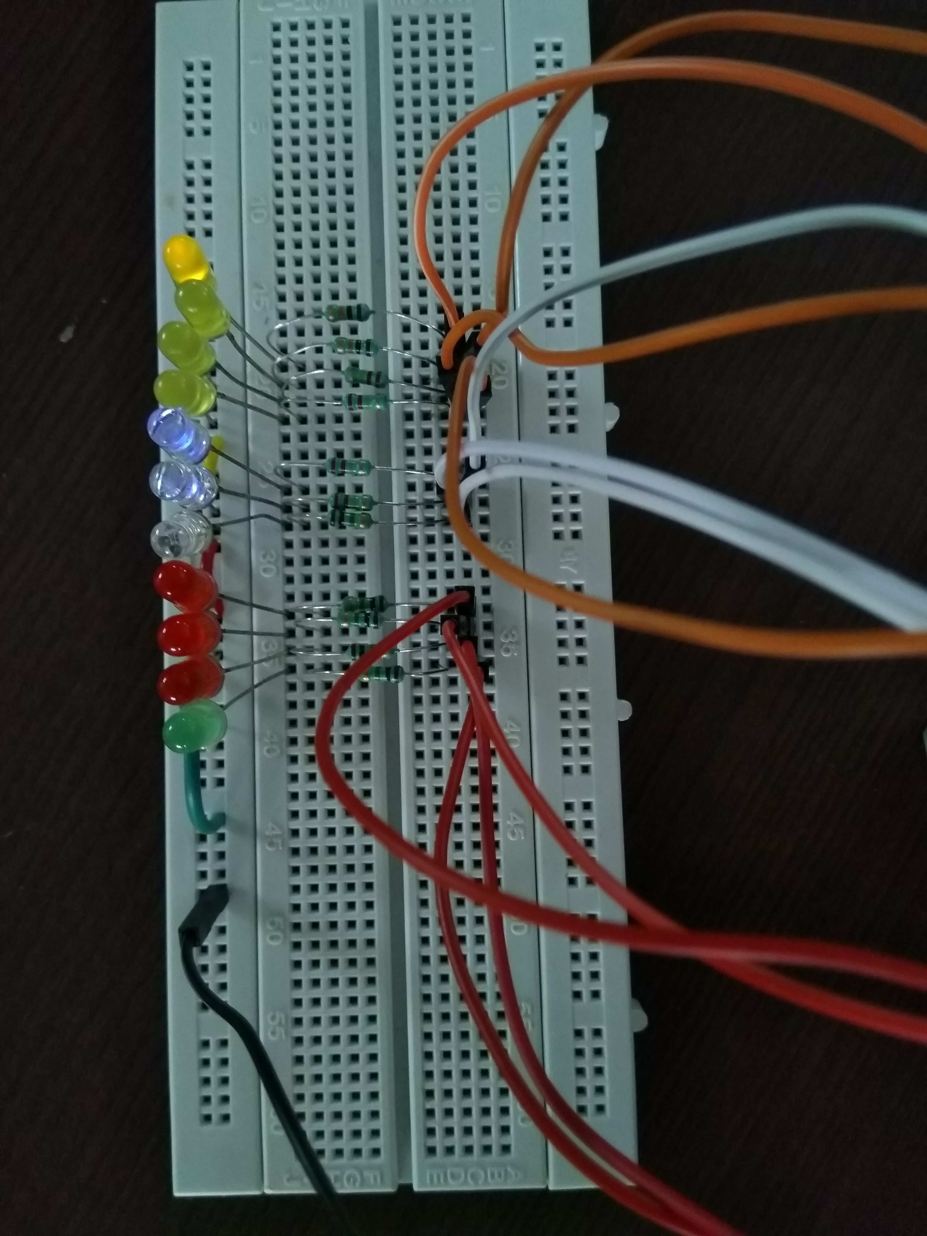

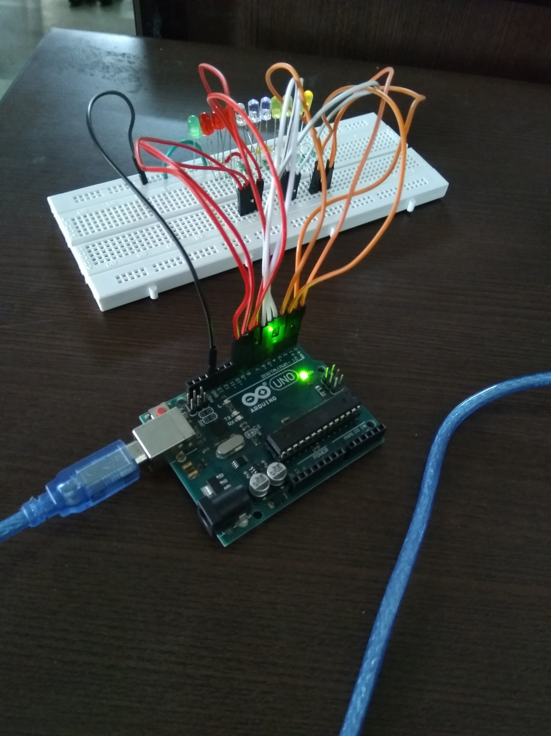

**Conclusion:**

We were able to make a VU meter using Arduino. This is a small scale implementation of the VU meter which can detect the audio voices / signals. The larger scale application includes that like using the meter in Diwali, festivals, ceremonies, sound mixing.

In this course we went through many Arduino tutorials as this was a very new concept for all of us. The glowing LEDs tell us the sound input in a visual format. Our sincere thanks to our Microprocessor and Interfacing faculty, Dr. Ushus Elizabeth who supported us throughout the course and kept us motivated.

**References:**

* VU Meter as a Monitoring Device for Indian Programmes *N. J. Nair, IETE Journal of Research, Published online: 21 Aug 2015*
* The working principle of an Arduino [*Yusuf Abdullahi Badamasi*](http://ieeexplore.ieee.org/search/searchresult.jsp?searchWithin=%22Authors%22:.QT.Yusuf%20Abdullahi%20Badamasi.QT.&newsearch=true)

*Nigerian Turkish Nile University, Abuja, Nigeria, IEEE*

* P. D. Minns, C Programming For the PC the MAC and the Arduino Microcontroller System. Author House, 2013
* M. Banzi, Getting Started with arduino. " O'Reilly Media, Inc.", 2009
* Working Principle Of Arduino And Using It As A Tool For Study And Research

*Leo Louis*

*Department of Electronics and Communication Engineering, Gujarat Technological*

*University, Ahmedabad, India*

* Programming with Arduino for Digital Humanities

[*Kazushi Ohya*](http://journalofdigitalhumanities.org/author/kohya/)*, Tsurumi University*

* [*http://www.instructables.com/id/VU-Meter-Using-Arduino/*](http://www.instructables.com/id/VU-Meter-Using-Arduino/)
* [*https://create.arduino.cc/projecthub/kj-electronics/uv-meter-music-visualizer-1-with-arduino-b16f5d*](https://create.arduino.cc/projecthub/kj-electronics/uv-meter-music-visualizer-1-with-arduino-b16f5d)
* [*http://ctc-dev.verkstad.cc/en/course-literature/vu-meter/*](http://ctc-dev.verkstad.cc/en/course-literature/vu-meter/)
* [*https://electronicsforu.com/electronics-projects/hardware-diy/arduino-based-audio-meter*](https://electronicsforu.com/electronics-projects/hardware-diy/arduino-based-audio-meter)